Low Concentrated P- and K-based Fertilizers for Localized Agricultural Supply Chains
Brenno C. Menezes,^{a,b*} Matheus Duarte,^{b,c} Caiubi Kuhn,^{d} Ana Gomes,^{d} Mohammed Yaqot,ª Kim Moloney^{e}
ªDivision of Engineering Management and Decision Sciences, College of Science and Engineering, Hamad Bin Khalifa University, Qatar Foundation, Doha, Qatar
^{b}Induagro, Production Planning and Supply Chain, Mato Grosso, Cuiaba, Brazil
^{c}Department of Civil Engineering, Federal University of Mato Grosso, Barra do Garca, Brazil
^{d}Department of Mining Engineering, Federal University of Mato Grosso, Cuiaba, Brazil
^{e}College of Public Policy, Hamad Bin Khalifa University, Qatar Foundation, Doha, Qatar
bmenezes@hbku.edu.qa
Abstract
Fertilizer can be made of organic materials like animal or green manure. However, such materials are less than 1% of total fertilizers worldwide. Instead, fertilizers are usually compounds of inorganic components based on nitrogen (N), phosphorus (P) and potassium (K) elements, forming the so-called NPK-fertilizer. Natural gas is the resource for N-based fertilizer plants producing ammonia and urea. On the contrary, for P and K components, mined from concentrated mineral reservoirs, their production is restricted to local producers where high levels of P- and K-based concentrated reservoirs are abundant. Concentrated mineral reservoirs of P-based components are mostly found in China and Morocco. K-based ones are largely located in Canada and China. NPK-based fertilizers can be blended to create a finished agriculture production input to be sold within a global market supply chain of fertilizers. However, we suggest something different. Localized supply chains of low concentrated fertilizers of P- and K-bases can be an option for agricultural sites. The non-metallic mineral mining reservoirs of the so-called agri-minerals or rock-for-crops are worth exploring by localized final consumers in the agricultural supply chain. Brazil is the world’s largest importer of fertilizers due to its thick and nutrient-depleted tropical soils. By mapping locations of natural resources and agricultural sites in the State of Mato Grosso (represents 30% of grains production in Brazil), we suggest a capacity expansion of processing plants connected to the natural resource sites of low concentrated agri-minerals and the distribution of the final processed product to the fertilizer end-use stage among local farmers.
Keywords: Supply chain, agriculture, fertilizers, agri-minerals, rocks-for-crops.
  - Introduction
The agriculture business operates in a frequent uncertainty given variations in the cost and supply of inputs (such as fertilizers in seasonal demand variations). Unexpected conditions, such as outbreaks and strikes, and disruptions in environmental conditions such as precipitation of rains, extreme weather events, among others, directly impact production performance. Fertilizers are a complex input for feed/food supply chains. This is because the natural resource reservoirs are based in a few countries worldwide. Fertilizer plays a vital role in ensuring plant growth and improved yields. Various factors influence the quantities, qualities, and properties for the use of fertilizer in the agriculture business. It includes the type of fertilizer, crop type, soil type, and nutrient requirements. Besides the carbon, hydrogen, and oxygen elements (captured by the plants from the atmosphere and water), numerous essential nutrients for plant growth and health are provided by fertilizers. The main components of fertilizer are nitrogen (N), phosphorus (P), and potassium (K). Secondary contributions include sulphur (S), magnesium (Mg), calcium (Ca), and several metals such as zinc (Zn) and iron (Fe). Mineral fertilizer plays an essential role in our food systems. It increases the volume of food that can be grown on a fixed amount of land. Approximately half the food we eat today has been produced thanks to mineral fertilizer (IFA, 2023). The maintenance of fertilizer production as essential to food security as it is for farmer livelihoods (Cordell et al, 2010).
International Fertilizer Association (IFA) indicated that in 2020, the global consumption of nitrogen, phosphorus, and potassium (NPK) fertilizers was approximately 184 million tonnes, 51 million tonnes, and 38 million tonnes, respectively. Furthermore, according to the Food and Agriculture Organization (FAO) of the United Nations, Asia is the largest consumer of fertilizers, accounting for about 60% of global consumption. China is the world’s largest consumer and producer of fertilizers, accounting for approximately 30% of global consumption and 33% of global production.
To reduce the imports of fertilizers and to increase the sovereign resilience of nations toward its feed/food production, localized supply chains of low concentrated P- and K-based fertilizers can be connected from the natural resources that feed the agri-minerals or rock-for-crops needs on agricultural sites. While it is worth exploring localized final consumers in the agricultural supply chain for the low concentrated P- and K-based fertilizer (LCPKF), there is a trade-off between the production and logistics costs. Considering that 90% of the LCPKF is made of non-useful materials such as sand or rocks without P and K-components, the processing and transportation costs may not be sufficient to fully replace imports of P- and K-concentrated fertilizers.
  - Worldwide agriculture and fertilizer production
The IFA estimates that 85% of global soils are deficient in nitrogen, 73% of the soils are deficient in phosphorus, and 55% lack potassium. Growing food in soil with a good balance of nutrients is key to preventing malnourishment and diseases caused by calorie deficiency. Figure 1 represents how much mineral fertilizer is applied to different crops.
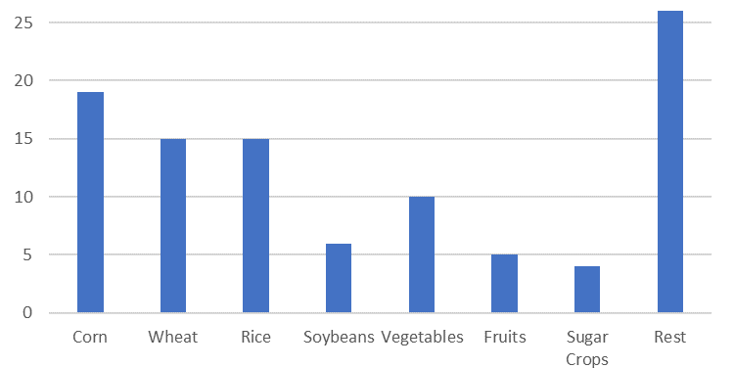
Figure 1. Utilization of fertilizers among crops/plants (IFA, 2023).

Understanding nutrient requirements of different crops is essential to plot the impact of nutrient-related policies and plan farming processes. It is also a prerequisite for other forms of market research and scientific assessment. Global balances of commodities for resilient supply chains for fertilizers in the feed/food lifecycle are necessary to understand if a country is to appropriately link resource availability, food security, and its fiscal bottom line. Global purchases of imported fertilizers cost a total US$151 billion in 2022 (Worldstopexports, 2023). The overall value of fertilizers imported in 2022 increased by an average 119.4% from all importing countries since 2018 when fertilizers purchases were valued at $68.8 billion. Year over year, international purchases of fertilizers accelerated via a 53.7% advance compared to $98.2 billion during 2021 (IFA, 2023). The biggest importers of fertilizers in 2022 were Brazil, India, USA, mainland China, and France. That cohort of major fertilizers buyers, as seen in Figure 2, provided over two-fifths (43.1%) of total international spending on fertilizers imported in 2022.

Globally, the ingredients to analyze agricultural businesses’ risks and trade-offs, or any sort of input and output are:

- Output 1: Levels of imports and exports on fertilizers. Inputs include (1) natural gas or concentrated rocks-for-crop fertilizer reservoirs, (2) number and wealth of populations, and (3) arable land in both size and soil quality and landscape.
- Output 2: Agricultural production. Inputs include (1) arable land; (2) number and wealth of population (3) fertilizers’ supply chains.
- Input-Output Processer: Fertilizer plants. Inputs: (1) global reservoirs of concentrated fertilizers (or natural gas for N-based fertilizer), (2) local reservoirs of P- and K-based fertilizers.

For localized fertilizer supply chains (SCs), the inputs and outputs of integrating fertilizers to agricultural output demands create the possibility of exploring low concentrated P- and K-based fertilizer SCs via locating processing sites near PK-reservoirs can assist agricultural production. By understanding the differences of production on the NPK-fertilizers (as seen in Figure 3) and the agriculture-fertilizer supply chain nexus at global and local scales, one can foresee research avenues that may diminish fertilizer import needs. One case is the road-mapping of the localized agriculture-fertilizer supply chain nexus in Brazil, in state of Mato Grosso, representing 30% of Brazil’s agricultural production overall.
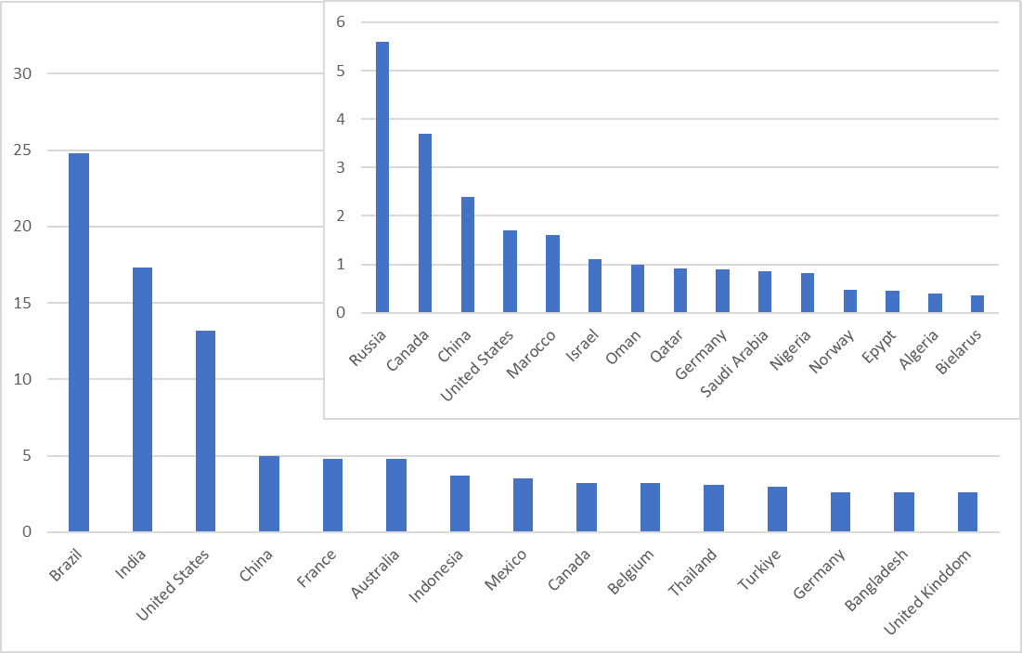
Figure 2. Fertilizer Imports by billions of USD (Worldtoexports, 2023).
  - NPK-based fertilizers
Among categories of imported fertilizers, almost three-quarters (73.6%) in 2022 were nitrogen-based products (IFA, 2023). Potassic fertilizers represent 23% of important compared to phosphatic fertilizers at 2.7%. Animal or vegetable fertilizers accounted for the remaining 0.8%. Although N-based are dependent on natural gas as a feed-process, the P- and K-based fertilizer components are mined from agri-rocks or rock-for-crops reservoirs (as seen in Figure 3). The fertilizer industry largely exports high concentrated P- and K-based fertilizer; however, there is the potential to explore locally produced low concentrated P- and K-based fertilizer (at 10% purity) if the logistics and transporting costs to nearby end-user farmers is financially feasible.
    - Nitrogen (N)
Nitrogen-based fertilizers are primarily manufactured through the Haber-Bosch process, a method developed over 100 years ago to create ammonia by heating and pressurizing nitrogen from the air over a hydrogen source (typically from natural gas or coal). The resultant ammonia is further processed to create nitrogen fertilizers in solid and liquid forms. Urea is the most produced and consumed nitrogen fertilizer globally while nitric acid-based fertilizers are also popular.
    - Phosphorous (P)
Phosphorus-based fertilizers are created from phosphate rock, which is a mined material. Phosphate rock is treated with sulfuric acid to separate the phosphorus. Phosphoric acid is created in this process, and can be further combined with ammonia and sulfur to create a variety of fertilizer products.
    - Potassium (K)
Potassium-based fertilizers originate from potash (potassium chloride), another mined material. Potassium chloride is processed into downstream products and granulated for ease of use and efficient uptake by plants.

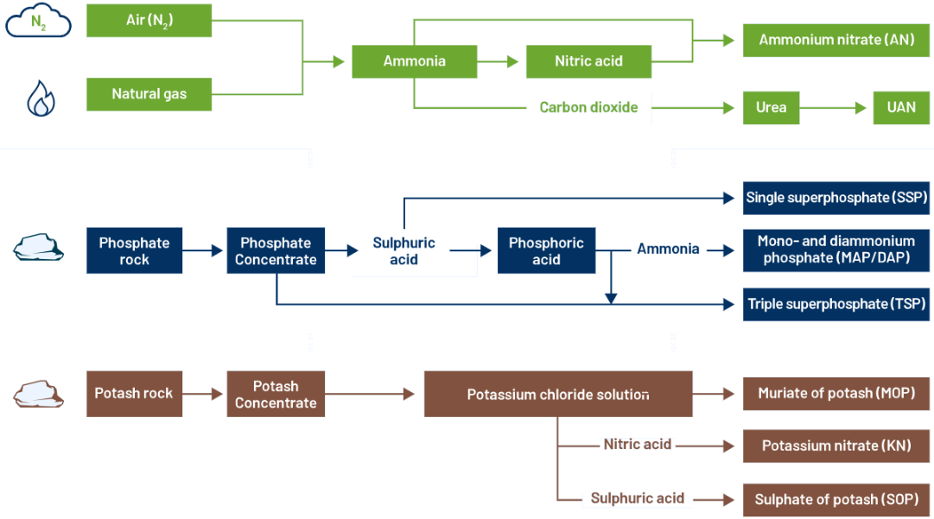
Figure 3. Schematics of the N-, P-, and K-based fertilizers.
  - Capacity expansion and distribution of low concentrated rocks-for-crops
Figure 4 shows the rain precipitation in Brazil for soybean and corn rotations and their seasons. Using the State of Mato Grosso as a case study and a typical farm in Brazil producing soybeans (1st production) and corn (2nd production) in 2019 (Langemeier, 2021), and considering the cost of imported fertilizers and the conditions of demands, climate, and other resources in the agriculture business, one can calculate the capacity installation needed for low concentrated P- and K-based fertilizers (LCPKF) and the range of their distribution in the State of Mato Grosso (as seen in Figure 4). There, huge reservoirs of low concentrated P- and K-based rocks for crops are recently under study to determine the purity and their impacts on the yields of soybeans and corn plantations.

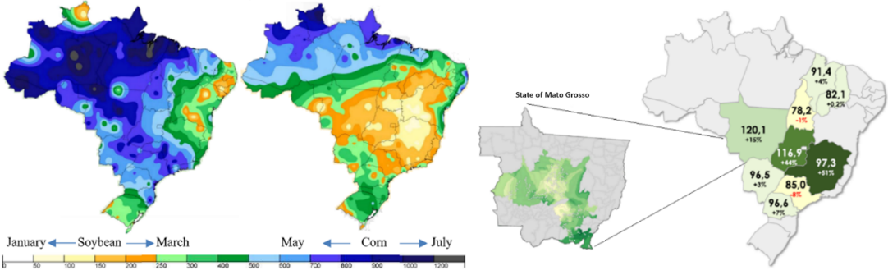
Figure 4. Rain precipitation for soybean and corn seasonal productions in Brazil.

Today the State of Mato Grosso, responsible for 30% of the agricultural production in Brazil presents one of the highest productivity on bushels per hectare (around 120) in the world. This near to Iowa and West Central Indiana (both in the United States) benchmarks. It is due to heavy Brazilian investments in both soil preparation but also via fertilizer imports. The creation of a LCPKF market will require regulation, public policy conversations, stakeholders meetings, and specialized consultancies to develop business plans for a new agricultural model based on localized P- and K-fertilizer solutions.
  - Public policies and international de-risk of feed and food supply chains
Robust, resilient, and adaptive public policies play a pivotal role in mitigating risks and ensuring stability within global feed and food supply chains. This is especially true for the global fertilizer market and the new potential for locally mined and produced LCPKA. This is a policy issue not just for local governments, local farmers, local miners, and local markets but also for national and international interaction. Food production is neither a local-only nor a global-only endeavor. It is a multilevel policy arena with a multiplicity of interested actors. Governments and international organizations can collaborate to craft comprehensive regulatory and policy frameworks for risk management, to anticipate and address disruptions in vital agricultural inputs like fertilizers, and to encourage local stakeholder discussions. To-date, there has been limited engagement of LCPKA from both the FAO and separately, the International Fund for Agricultural Development. It is also an under-researched policy arena for governments and related actors. This limited discussion carries forward to the agricultural nations, like Brazil, which important significant amounts of high concentrated fertilizer from abroad (25 billion USD/year).

Governments and interested actors may wish to employ any number of potential policy tools. Regulatory tools may include new laws, direct regulation, indirect regulation, voluntary regulation, incentive-based regulation, licenses, quotas, public consultations, and even the creation of associational actors. If appropriately utilized, regulatory tools can incentivize transparency, fair competition, and sustainability in the fertilizer market. Financial tools include encouraging public investments in research, innovation, and alternative technologies. It may also include public-private partnerships, cash-based direct transfers, grants, subsidies, tax incentives, and where appropriate, user fees. Information tools include instruments that disseminate information (moral suasion, government billboards, pamphlets, and product labelling), collect information (statistical and national planning agency involvement and increased data collection), and release information (polling, Freedom of Information Acts, stakeholder willingness to blow the whistle, and investigatory means). Each policy tool option (regulatory, financial, information) requires careful consideration, consultation with involved actors, and a flexible policy design whereby the policy mixes appropriate for LCPKA are created.

Questions about whether to exclusively import highly concentrated fertilizer from abroad or to create LCPKA via new local producers will rarely find a single answer. Instead, policy conversations are required. Such conversations should encourage fertilizer source diversification, local developments where agri-minerals or rock-for-crops are present, appropriate investment climates for such new developments while ensuring any resulting trade practices are equitable to farmers of all sizes. Appropriate policy tool selection and local-international collaboration are key contributors to LCPKA market creation.
  - Conclusions
Given the extensive exploration of fertilizer dynamics and global agriculture presented in this paper, it is evident that localized supply chains for low-concentrated P- and K-based fertilizers could offer strategic solutions amid uncertainties. The existing centralized production, coupled with a heavy reliance on imports, poses challenges to stability and sustainability in agricultural supply chains. Despite the potential production and transportation costs in establishing localized chains, leveraging non-traditional resources like low concentrated agri-minerals or rock-for-crops presents a promising alternative. However, such a shift will demand meticulous attention to regulatory framework development and the public policies that can foster collaboration, transparency, and equity-focused trading practices. Robust international cooperation and investments in research and innovation will be pivotal in fortifying global food security and mitigating vulnerabilities within agricultural supply chains while laying the groundwork for a resilient and sustainable future.
References
D. Cordell, J. Drangert, S. White, 2009, The story of phosphorus: Global food security and food for thought, Global Environmental Change, Volume 19, Issue 2, 292-305,
IFA, 2023, International Fertilizer Association, accessed on 20/11/2023 at: www.fertilizer.org.
M. Langemeier, 2012, International Benchmarks for Corn Production (2021) - Purdue Center for Commercial Agriculture: https://ag.purdue.edu/commercialag/home/resource/2021/06/international-benchmarks-for-corn-production-2021/
Top Fertilizers Imports by Country 2022, , accessed on 21/11/2023 https://www.worldstopexports.com/top-fertilizers-imports-by-country/?expand_article=1
Rally da Safra. Rally da Safra 2024 - Uma viagem pelo Brasil que produz Resultados da Safra 2022/2023. Accessed: http://rallydasafra.com

